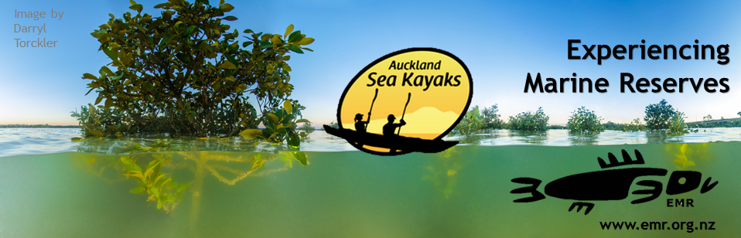
Free Community Guided Kayak Day – Participation by koha/donation

Explore one of the hidden gems of the Hauraki Gulf, one of our most visited marine reserves with experienced kayak guide. You never know what you might spot! Kayak through mangrove forests. This event is a taster into kayaking - expect to spend ~40mins on the water.
Fun for the whole whanau – recommended for children over 7.
Children under 13 need an adult companion. Registrations are essential. Only 48 spots available. Sea conditions permitting.
This event is funded by The Bobby Stafford-Bush Foundation.

Information:

Location: Eric Armishaw Reserve, Pt Chevalier, Auckland
Date: Sunday 14th October 2018
Time: Sessions are 10.00am, 11.15am, 12.30pm – arrive at least 20mins prior
Parking: In the park – Car park
Numbers limited to 48
Individual gear list:

- Bring footwear for kayaking (boat shoes, sandshoes or booties).
- A spare change of clothes in case you get wet.
- A hat and sunglasses recommended a leash for prescription glasses or expensive sunglasses recommended.
- Wear shorts or long pants (no jeans).
- Apply sunblock before the event.

Event Terms:

Lifejackets provided.

Activity recommended for 7 years and up. Children under the age of 13 must be accompanied by an adult participant to ensure adequate ratio. Advanced safety procedures will be in place on the day.

Postponement (weather):
You will get a warning email 2 days prior if weather forecast not looking favourable for the site. Final call will be made on the morning of the event by 8am. Postponements will be sent via email (so you will need to make sure you can access your emails that morning) and will also be posted on our
website http://www.emr.org.nz and Facebook page https://www.facebook.com/emr.mtsct. If no email contact or website/Facebook notice received, expect that event is going ahead as planned.

Participant cancellation:
We require an email or phone call no later than the evening before the event if you have to cancel.
Please note that late cancelations or ‘no shows’ may affect your future participation at events such as these. Hopeful participants will miss out on participating if inadequate notice is given.

Kayak Day lead organiser: Lorna Doogan
Email: auckland@emr.org.nz
Cell: 02102732339

Terms and conditions
RISK INFORMATION:
You need to be aware that sea kayaking and its associated activities have inherent risks of danger.
Sea kayaking in Auckland can be subject to rapidly changing weather and water conditions.
The staff and management of Auckland Sea Kayaks (A.S.K.) take all practicable steps to identify and minimise
potential dangers; however there still remains an element of risk. Accordingly, you must follow the guide’s pre-
trip safety briefing instructions and adhere to safety requirements at all times.
If you have any concerns or questions please feel free to discuss them with your guide at the end of the safety
briefing.
TERMS AND CONDITIONS:
By signing this form below, you agree:
• to indemnify A.S.K. and its staff against liability resulting from any failure by you to follow our instructions or
the failure of any person accompanying you under the age of 18 to follow our instructions;
• that A.S.K reserves the right to withdraw persons, cancel or modify the trip, as the situation may require,
when in our opinion there is a safety issue;
• that A.S.K. may render first aid and seek medical assistance or means of evacuation as required, and to the
extent the medical treatment or evacuation pertains to you, you undertake to pay medical treatment and
evacuation costs;
• that A.S.K. will not be liable for damage to your property, disruption to your travel plans, or any other loss,
except as provided in law.
IMPORTANT LEGAL INFORMATION:
• A.S.K. strongly recommends that all visitors to New Zealand have full insurance coverage for medical
treatment and loss resulting from any potential injury sustained.
• The information in this form will be used only by A.S.K. and held in accordance with the Privacy Act.

